Implementing Best Practice for Peripheral Intravenous Cannula (PIVC) Use in Australian Emergency Departments: Communication plan for Monash Health implementation phase

Introduction
This project centres on accelerating and improving implementation processes in the healthcare setting, with a focus on reducing unnecessary cannulations and excellence in care and maintenance.
Historically, changes of this magnitude can take up to 17 years to fully implement; however, this trial aims to reduce that timeframe to just three years by testing and applying best practice methodologies in implementation science and behaviour change strategies.
The first phase of implementation will take place within the three Emergency Departments (ED) at Monash Health, and then extend to other hospitals nationally.
This trial aims to reduce unnecessary peripheral intravenous catheter (PIVC) (cannula) insertions in emergency departments (EDs) across Australia, which will lead to safer patient care, fewer infections, and better use of healthcare resources. By ensuring that PIVCs are only inserted when needed, the trial will improve patient outcomes and reduce avoidable risks.
The study will measure how well the intervention works by tracking the reduction of unnecessary PIVCs, increased utilisation of those inserted, and overall patient safety. It will also look at cost-effectiveness and environmental impacts. The goal is to roll out the approach to EDs across the country, creating better, safer practices for healthcare professionals to follow.
While this trial commences in the ED it is a whole health service project as consumers with ED PIVCs are admitted to inpatient settings and ongoing care and maintenance is key to safety.

Background
Avoiding unnecessary cannulation has been well-established and widely recognised as beneficial in emergency care settings. It is supported by evidence-based guidelines and advocated by the Australian Commission on Safety and Quality in Health Care (ACSQHC) and the World Health Organization (WHO). These guidelines promote clinically appropriate cannulation to reduce patient harm, minimise infection risks, and improve overall care outcomes. Following these recommendations not only ensures better patient safety and comfort but also aligns with global best practices for delivering efficient, high-quality healthcare. The key benefits of eliminating unnecessary cannulas include:
- Reduced patient discomfort: Inserting a cannula unnecessarily can cause pain and discomfort for patients.
- Lower infection risk: Every peripheral intravenous catheter (PIVC) carries a risk of infection, including serious complications like bloodstream infections. Reducing unnecessary cannulations minimises these risks, helping to improve patient safety and reduce hospital-acquired infections.
- Target ZERO for serious hospital acquired bloodstream infections form PIVC
- More efficient use of resources: Inserting, maintaining, and removing cannulas that are not used wastes time and resources for healthcare teams. Eliminating unnecessary cannulas frees up valuable time, allowing clinicians to focus on more critical aspects of care, leading to greater operational efficiency.
- Cost savings: Lowers the costs associated with consumables as well as the labour involved in their management.
- Environmental impact: reduced use of consumables, together with reduced waste.
- Aligning with best practice guidelines: aligns with evidence-based guidelines such as those from the Australian Commission on Safety and Quality in Health Care (ACSQHC).
This project is funded by Medical Research Future Fund (MRFF), Australian Government, Department of Health and Aged Care for $2.9 million over 5 years (2023-2028).

Timeline
- Early to Sep 2024: communications with ED teams at Monash Health centred on improving documentation of cannula use to establish baseline (in place).
- October 2024: implementation trial begins at Monash Health Emergency Departments (three EDs).
- October 2024-December 2024: Dedicated Monash Health implementation period.
- December 2024: Alfred Health and Eastern Health implementation period begins.
- February 2025: Queensland Health and Tasmania Health implementation period begins.
- Feb 2025 to April 2027: Implementation period continues across all health services.
- April 2027: Implementation trial period concludes.
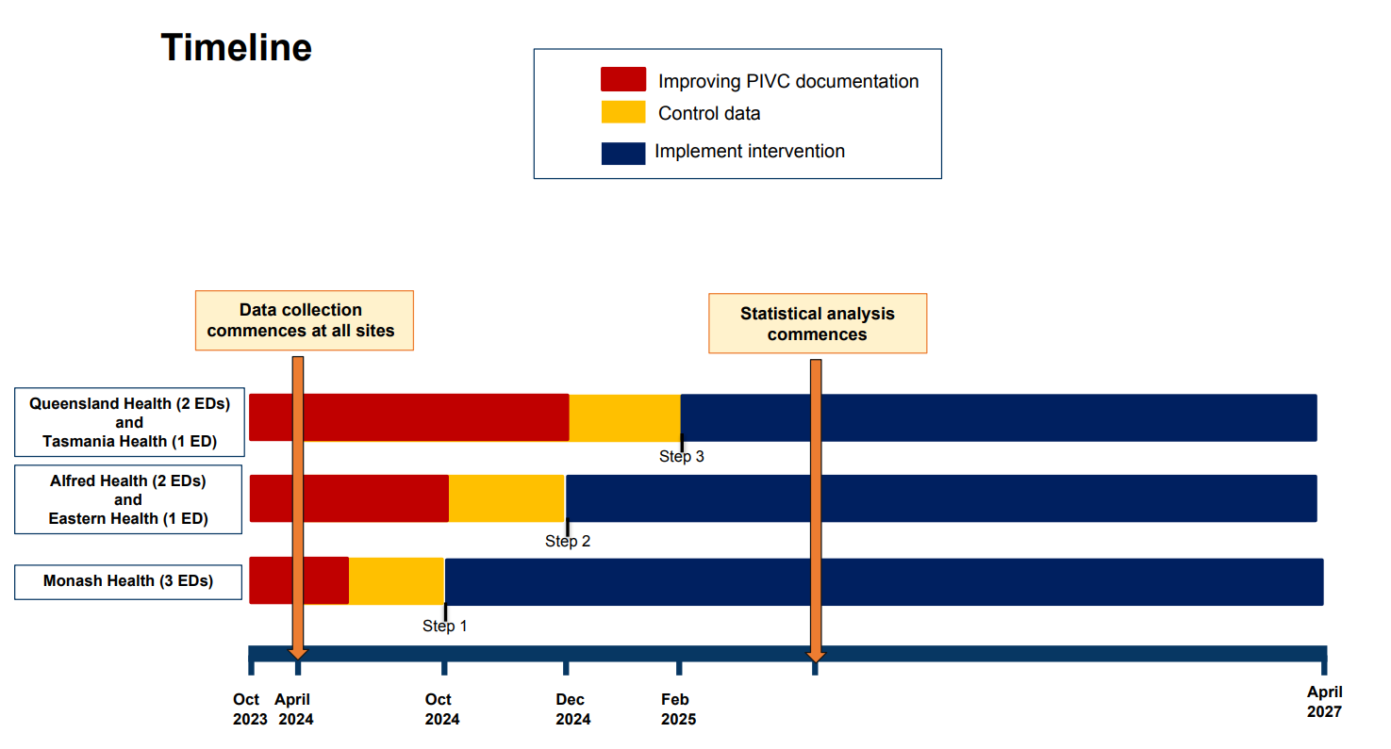

Challenges and considerations
While this project has broad application through most areas of the health service, this trial is focussed on behaviour change with the ED. Monash Health communications will not be able to target the ED environment exclusively, therefore, it will be important to ensure all messaging is also suitable for a broad employee, patient and public audience.

Budget
Materials required for communications will be covered by the project grant.

Project leads
- Professor Diana Egerton-Warburton OAM, Director of Emergency Medicine Research, Medical Co-chair of Monash Emergency Research Collaborative
- Sundy Ni-Yen Yang, Senior Project Manager, Department of Emergency Medicine
- Sue Bumpstead, Research Coordinator, Emergency Medicine

Executive sponsor and sign-off requirements

Executive sponsor: Andrea Rindt, Chief Operations Officer
Initial minimal sign-off​ required (for all content to be shared with a broad Monash Health audience)
- Any person featured or quoted in the content (if applicable)​
- Local content expert or owner
- Director, Communication and Engagement / Senior Media Manager​
Final sign-off​ (prior to publication, once initial sign-off is in place)
- Content expert of at least General Manager or Program Director level.

Stakeholders / Audiences
Primary:
- Clinical teams within the Monash Health ED
- Monash Health leadership
- Monash Health ED patients and carers or families
Secondary:
- All other clinical teams within Monash Health
- All other patients within Monash Health , their families and carers

Communications strategy goals
- Reduce unnecessary cannulations
- Target ZERO hospital acquired bloodstream infections form PIVC
- Increase clinical team awareness regarding the importance of eliminating just-in-case cannulas
- Increase patient awareness around cannula use, and provide reassurance that they can ask their team whether a cannula is still needed or required at all at the time of insertion
- Provide a foundation for the successful rollout of the project across other hospital EDs.

Channels and supporting resources
Channel | Role | Details
Targeted email to ED leads | Build awareness on major milestones and dates | As required, to be sent directly by project team.
iNews | Build general awareness and provide an easy landing page | Housed on the intranet homepage, useful point of reference to link to.
Insight newsletter | Repeat exposure the above iNews piece/s. | Sent out Friday every week, automatic repeated content
Employee Forum | Share overview with broad community | Every Tuesday at 2:00 pm
745 Leadership Update | Share update with Monash Health senior leadership | Every Monday at 7:45 am
Meeting: Leadership Live | Share update with Monash Health managers | Every 2nd Wed at 2:00 pm
CMO Newsletter | Communicate with clinical and related teams (reshared iNews pieces). | Thursday 3:00 pm each week
*Intranet homepage | Central space for employee facing materials and news | Banners/tiles to key landing pages or promos.
*Screensavers | Target employees at their computers. | Rotating campaign tiles, upload via central platform
Newsletter: VHH | Ad-hoc email to VHH cohort | Previously weekly, now sent as needed
Newsletter: Quality Care | Reach Monash Health clinicians. | Managed by Ops Comms Team, ad-hoc timing.
Meetings: Tier 4 | Reach Tier 4 leaders | Agenda items to be requested to Stephanie Pierce by Tier 4 member
*Print collateral | Includes posters, brochures, flyers and other collateral | Can be designed by Creative Team, print and distribution costs/arrangements to be covered by stakeholder.
*Digital screens | Reach employees and patients within wards and our hospital | Located throughout facilities to be designed by Creative team.
*Will require input from Monash Health’s design and creative team.

Communications schedule

Channel | Description | Date / Timing
Targeted email to ED leads | Announcement that trial begins soon, with key points to share with teams for huddles. | Monday 17 Sep
iNews | Trial coming soon; Trial begins today (repeat piece with edited intro) | 24 Sep; 1 Oct
Insight all-employee newsletter | Reshared iNews piece from above. | 1 October
Employee Forum | To request a project update section, will be at the discretion of Exec and in view other content. | 1 October
745 Leadership Update | To request an item within the agenda, trial begins tomorrow. | 30 Sep
Meeting: Leadership Forum | Fast News items (top-level reminder as part of top news) | 8 Oct
CMO Newsletter | Reshared iNews pieces | 24-27 Sep
*Intranet homepage | Homepage tile (image on the homepage linking to the iNews article) | 1 Oct
*Screensavers | To be designed by the digital team (mock-up below) | 1 Oct – 31 Dec
Newsletter: VHH | Only if VHH is a cohort audience, date will depend on when the next issue is due. | October (TBC)
Newsletter: Quality Care | Ad-hoc publication, will need to check if an issue is due at this time. | October (TBC)
Meetings: Tier 4 | To request a reminder for Ops leaders from COO | 1 Oct
*Print collateral | Posters in EDs including consumer information sheet | 1 Oct- 31 Dec
*Digital TV screens | Promotional campaign slide during the month of Oct, will be both employee and patient facing through all sites. | 1-31 October

Proposed content (for review)

iNews story & media release (employee audience):

The end of the ‘just-in-case cannula’ begins this October

Did you know that nearly half of the peripheral intravenous cannulas (PIVCs) inserted in emergency departments go unused? Starting 1 October, we’re coming together to put an end to the ‘just-in-case’ cannula and taking action for safer care and a better experience for our patients.
Leading the way for change
Peripheral intravenous cannulas cost Australian emergency departments (ED) up to $594 million annually. Astonishingly, nearly $306 million of that is attributed to cannulas that are never used. Beyond the financial burden, unused cannulas create significant environmental waste, take up around 11,790 days of clinician time annually and expose patients to complications like bloodstream infections. Reducing the insertion of unused cannulas is not only a patient safety issue but an urgent economic and healthcare priority.
Professor Diana Egerton-Warburton, Director of Emergency Medicine Research at Monash Health has been passionately leading change in this space and this year the Multidisciplinary Project Team PIVC investigator Group is excited to be launching a transformational implementation science trial funded by a $2.9 million grant from the Medical Research Future Fund (MRFF).
This five-year study will focus on improving the use of PIVCs in Australian EDs. The trial will aim to reduce unnecessary PIVC insertions and improve patient care, with the ambitious goal of rolling out these best-practice guidelines to 50% of EDs nationally.

What is happening
The Just say no to the ‘just-in-case’ cannula campaign will roll out to nine Australian EDs. Phase one of the trial begins on 1 October at all Monash Health Emergency Departments and will signal the implementation of several initiatives in Monash Health EDs. This will include:
- Auditing and improving IV trolley equipment and layout.
- Updating the PIVC online learning package for staff.
- Revising our PROMPT policy to ensure best practices.
- Improving how cannula documentation is recorded in the Electronic Medical Record (EMR) to align with the ACSQHC standard
- Improving cannula care and maintenance within the health service by the introduction of the iDECIDED tool on the EMR interactive view
- Offering clinical education sessions to our teams.
- Distributing co-designed informational posters for patients.

What you need to do
Please help us to eliminate unnecessary PIVC use and improve patient safety and care by always:
- being 80% sure that a cannula is clinically necessary for treatment before insertion
- considering alternate medication routes other than IV
- documenting cannula use in the EMR every time
- avoiding flexion points when a cannula is required
- talking to your patients when a cannula is required, ensuring they understand the clinical benefits and that they feel welcome to ask questions or raise concerns prior to insertion.
Together, we look forward to setting new best-practice standards not only within Monash Health but across Australia, ensuring safer care and better outcomes for patients and their families.

Approved by [please insert name and title of General Manager or Program Director or above, authorising the publication of this article]

Short 100 word blurb for newsletter teasers (i.e. Insight Newsletter, CMO News) – employee audience

The end of the ‘just-in-case cannula’ arrives this October
Did you know that nearly half of all peripheral intravenous cannulas (PIVCs) go unused? On 1 October, the Just say no to the ‘just-in-case’ cannula project will launch across Monash Health's Emergency Departments. Led by Professor Diana Egerton-Warburton, this initiative will aim to improve patient care and safety by putting an end to unnecessary PIVC insertions. Funded by a $2.9 million MRFF grant, the five-year implementation science trial will aim to roll out best-practice guidelines to EDs nationally by 2027.
Learn more about the changes coming to our EDs

Update on the Launch

Last week the Just say no to the ‘just-in-case’ cannula project was launched across Monash Health. The hybrid launch event was attended by more than 150 attendees. The implementation science trial is MRFF funded and its overall aim is ensuring excellence in Peripheral Intravenous Cannula (PIVC) care with alignment to the ACSQHC 2021 Clinical Care Standard. Monash Health research informed this standard and has been cited in recent WHO guidelines on preventing bloodstream infections from PIVCs.
The key messages were highlighted by CEO, Eugine Yafele, “fewer, cleaner, smarter cannulas”. He emphasised that a whole hospital approach is needed, ongoing care and maintenance is vital to ensure we reduce risks of PIVC complications particularly hospital acquired bloodstream infections. We heard from a consumer whose wife experienced this type of infection and the impact it had.
Professor Diana Egerton-Warburton called for a shift in how we think about patient care, reducing low value care by questioning whether a cannula is necessary. It’s good for the consumers, the health services and the planet. A health economic analysis and national roll out will be part of the project.

Website story for monashhealth.org (public facing)

Let’s say no to the ‘just-in-case’ cannula
Did you know that nearly half of all IV cannulas (the plastic tubes inserted into patients' veins to give them medicines and fluids or to carry out procedures) inserted in emergency departments across Australia are not used?
Beginning 1 October, we’re launching an exciting project to reduce the use of unnecessary cannulas and provide safer care and a better experience for our patients.

Why this matters
Unnecessary cannulas can cause discomfort, pain, and increase the risk of serious infections. Every cannula inserted carries a potential risk, so avoiding them when they're not needed helps keep patients safer.
Eliminating unnecessary cannulas also allows our healthcare teams to spend more time on patient care, using resources more effectively to support you and all other patients. It's about providing safer, more efficient care for every patient.

What you can do
We encourage you to join the conversation and help us reduce the use of unnecessary cannulas. We welcome you to:
- ask your nurse or doctor why you are getting and IV cannula
- ask if there is an alternative, for example, you can ask, “can I have oral medications instead”?
- tell your nurse or doctor if you have any concerns with your cannula, especially if it hurts.
By reducing unnecessary cannula use, we’re creating a safer, more efficient, and patient-centred approach to emergency care, together.
For more information download the Best Practice for Intravenous Cannula Use in Emergency Departments - Information for Consumers

Email to Monash Health ED Leadership (week before launch)

Dear colleagues,
I am writing to share that the Best Practice for Intravenous Cannula Use in Emergency Departments project (Just say no to the ‘just-in-case’ cannula campaign) will officially launch across all Monash Health Emergency Departments this coming Tuesday 1 October.
As you know, this initiative aims to reduce unnecessary peripheral intravenous cannula (PIVC) insertions, improving both patient safety and care efficiency. The key focus is to minimise patient discomfort, reduce infection risks, and optimise our use of time and resources with an expected rollout 50% of EDs nationwide.
Key actions for you and your team
Please ensure you speak with staff in your area before 1 October, remind them of the project rollout at Monash Health ED and of key actions for them, which are to:
- Be at least 80% sure that a cannula is clinically necessary before insertion.
- Consider alternate medication routes instead of IV whenever possible.
- Document all cannula use in the EMR every time.
- Avoid flexion points when inserting cannulas.
Please also remind them to discuss cannula use with patients, ensuring they take the time to explain the clinical reasons for cannula insertion and that patients have the opportunity to ask questions or raise concerns.
Your leadership is vital to the success of this project and we greatly appreciate your support.
If you have any questions, please don’t hesitate to contact me.
Thank you for your continued support.
Kind regards,

Computer screensaver (employee-facing)
As an employee-facing channel, these screens should have a message that provides a short clear message for staff on the key steps to remember, which can be read in a few seconds.
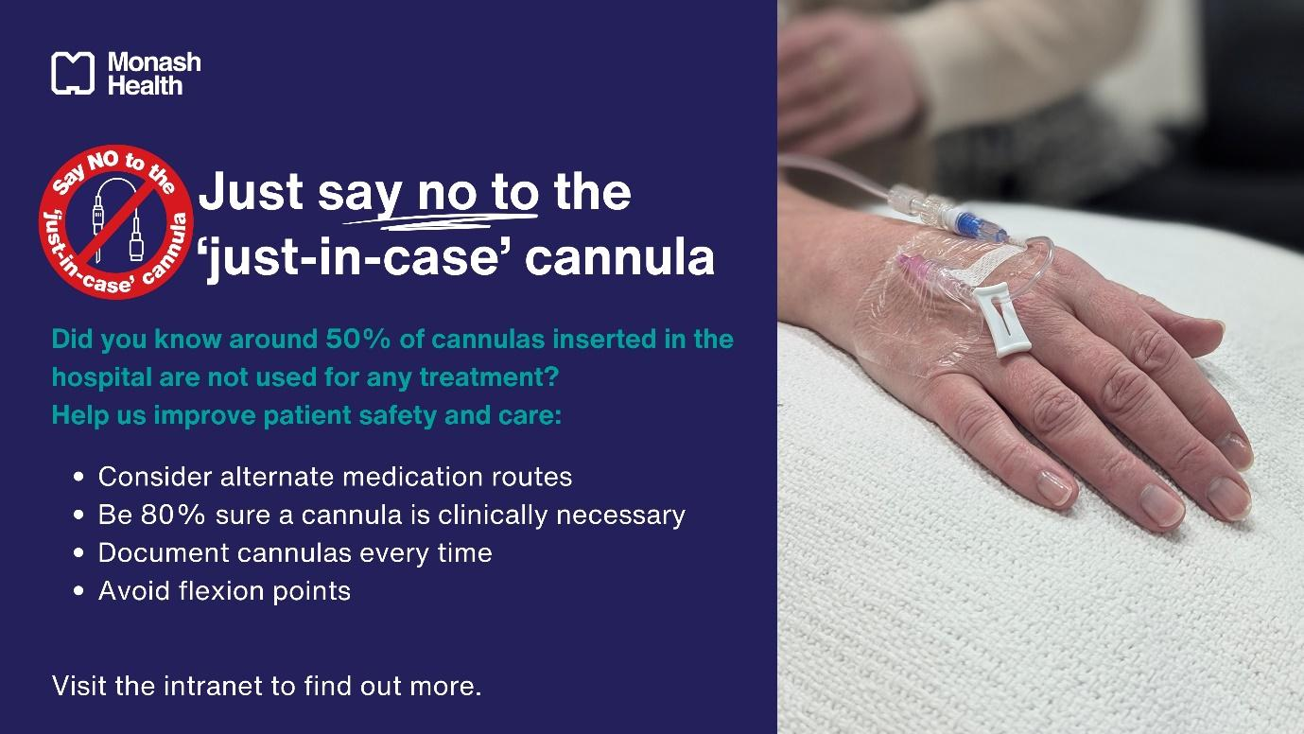

Corporate TV screens (both patient and employee facing)
As a channel that will reach both employees and patients from across the organisation, across multiple sites, this message needs to be softer. It needs to create awareness while maintaining trust in Monash Health’s clinical teams and their ability to make decisions. It should be positioned as a joint effort between the health service and patients.

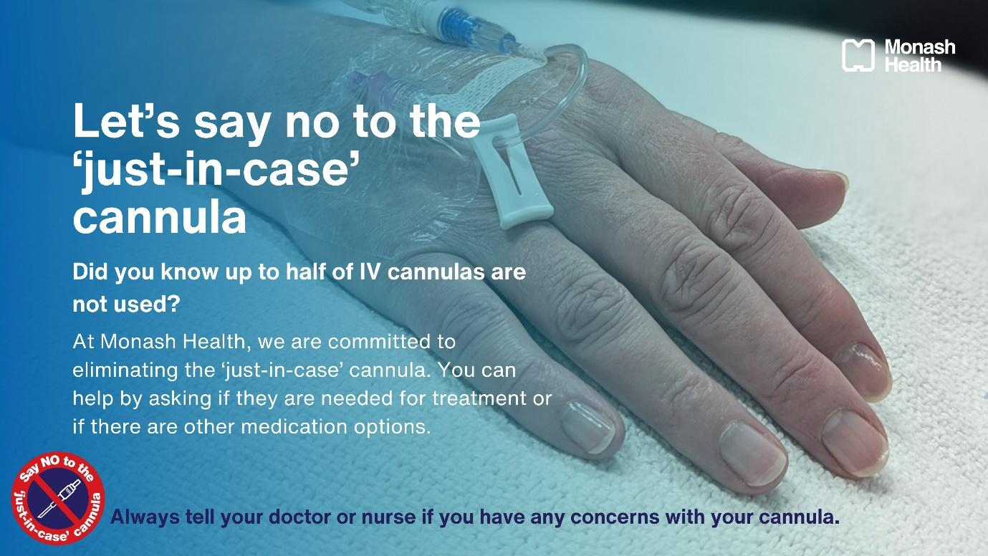

Poster for displaying in EDs (both patient and employee-facing):
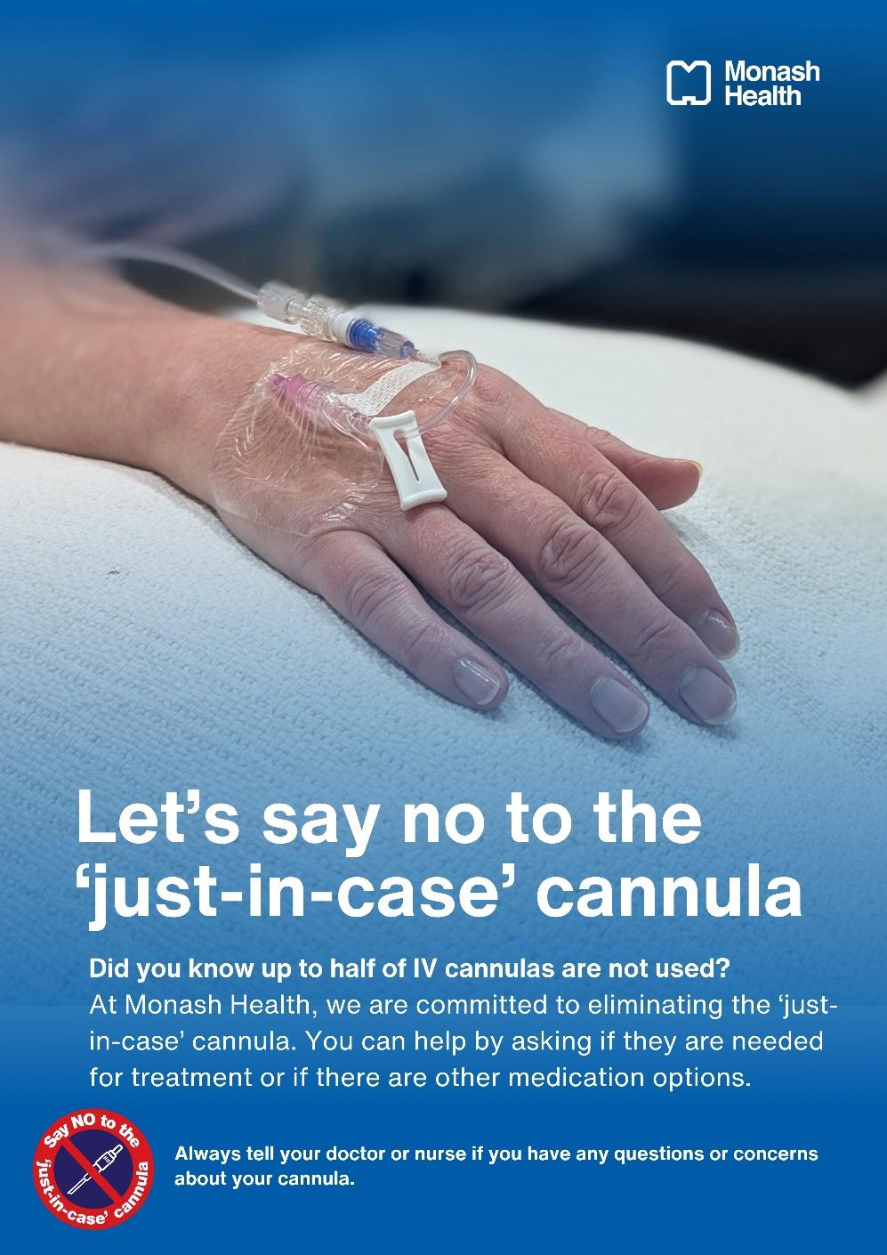

Implementation trial poster for consumers:
This will be rebranded and designed by the Monash Health design team, using the below approved wording. 