PROCEDURE

Selection of appropriate peripheral venous access for imaging examinations (Adult)
TARGET AUDIENCE and SETTING 1
PURPOSE 1
ABBREVIATIONS 1
PRECAUTIONS 2
STANDARD REQUIREMENTS 3
PROCEDURE 3
RELATED DOCUMENTATION 4
KEY STANDARDS, GUIDELINES OR LEGISLATION 4
REFERENCES 5

TARGET AUDIENCE and SETTING
Monash Health Nursing and Medical staff, Medical Imaging Technologists and Nuclear Medicine Technologists inserting a peripheral intravenous cannula (PIVC) for imaging examinations, within their scope of practice.

PURPOSE
Patients attending Radiology frequently require intravenous access for administration of contrast media or radiopharmaceuticals to undertake the requested examination.
This procedure will assist clinicians with PIVC selection and insertion site prior to attending for imaging examinations which require contrast media or radiopharmaceuticals, such as contrast enhanced CT, MRI or Ultrasound scans, or Nuclear Medicine examinations.

ABBREVIATIONS
CCTA – Coronary Computed Tomography Angiography | MRI – Magnetic Resonance Imaging
CT – Computed Tomography | mSv – millisieverts
CTA – Computed Tomography Angiogram | NM – Nuclear Medicine
CTPA – Computed Tomography Pulmonary  Angiography | PIVC – Peripheral Intravenous Cannula
EMR – Electronic Medical Record | US – Ultrasound
G – Gauge | Yrs – Years

PRECAUTIONS
Intravenous contrast extravasation into the subcutaneous tissue occurs in less than 1% of patients¹. In most cases, extravasation injuries are mild, however, they often lead to either poor quality imaging that affects the diagnostic accuracy OR the need to repeat imaging which then constitutes a radiation incident if ionising radiation has been used. Radiation incidents are reportable to the Department of Health if the patient has received an additional 1mSv of radiation that was unintended².
Risk factors of extravasation include ^{3, 4}:
- Use of small, fragile or previously damaged veins, or altered circulation in the injected extremity
- Insertion of PIVCs at points affected by motion of limb
- Altered communication or impaired cognitive function
- Inadequate dressing and securement of the PIVC
- Lack of patency of vascular access device
- Obesity
- Large volume contrast administration via pressure injector at high injection rates
- Older age
- Female sex
- Age of existing cannula
- Cannula site other than antecubital fossa
Note: If extravasation occurs, Management of Intravenous Contrast Media Extravasations procedure must be followed.
Extravasation events must be entered into RiskMan and documented in the affected patient’s EMR file. All radiation incidents must be entered into RiskMan for tabling at the monthly Imaging Radiation Safety Committee meeting.
Contrast media hypersensitivity reactions are infrequent and predominantly mild in nature. Incidence varies dependent upon contrast agent:
- Iodinated Contrast Media – ALL reactions 1-12%, Severe 0.01-0.2%⁵
- Gadolinium-Based Contrast Media – ALL reactions 0.004-0.7%, Severe 0.01%⁶
- Perflutren Contrast Media (Ultrasound) – ALL reactions 0.01%, Severe 0.006%⁷
Prior to cannulation, patients must be asked if they have a known contrast allergy or any issues following a previous examination when contrast was administered.
Should the patient report a previous contrast reaction or there is suspicion of a contrast hypersensitivity, the referrer must discuss the need for imaging with a Radiology Registrar, Fellow or Consultant to determine if an alternative non-contrast imaging examination is sufficient OR if a substitute test performed in a different modality is appropriate OR if the prescribing of corticosteroids and/or antihistamines to reduce the likelihood of anaphylactic reaction is appropriate for the individual patient. In the event pre-medication is required, the Iodinated Contrast Media Pre-medication Management for imaging procedures OR Pre-medication for an Imaging Procedure with gadolinium-based contrast used in MRI procedure must be followed.
The cannula and extension tubing must be connected firmly and adequately secured to the patient to prevent either leakage of contrast from the connection site and/or movement during power injection of contrast, thereby reducing the risk of non-diagnostic examinations and/or extravasation and subsequent potential radiation incidents.

STANDARD REQUIREMENTS
When undertaking any clinical interaction with a patient, staff are expected to:
- Perform routine hand hygiene. Refer to the Hand Hygiene Procedure.
- Introduce themselves to the Patient and Carer/Family if in attendance.
- Explain what their role is and what you are there for
- Check patient identification. Refer to the Patient Identification Procedure.
- Obtain verbal consent as per the Consent to Medical Treatment Procedure.
- Keep the patient/carer informed and involve them in decision making.
- Document PIVC insertion in the EMR

PROCEDURE
PIVC gauge and location is to be considered on a case-by-case basis for each patient and requested examination. Whenever possible, areas of flexion must be avoided, as per the ACSQHC Management of Peripheral Intravenous Cannulas Clinical Care Standard. If unsure of the cannula size and required insertion site, please discuss with the relevant Medical Imaging Technologists/Nuclear Medicine Technologists /Sonographers prior to inserting the cannula.

FACTORS TO BE CONSIDERED FOR SITE SELECTION AND CANNULA GAUGE
- Requested radiology examination
- Availability of suitable vessels for cannulation
- Urgency to obtain intravenous access
- If PIVC will be used for additional treatment (rapid fluid infusion)

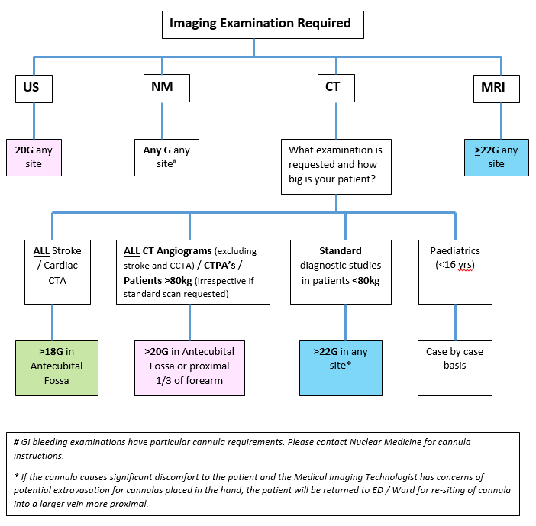

RELATED DOCUMENTATION
Peripheral Intravenous Cannula (PIVC) Insertion, Assessment and Management (Adult)

KEY STANDARDS, GUIDELINES OR LEGISLATION
Australian Commission on Safety and Quality in Health Care (2021). Management of Peripheral Intravenous Cannulas Clinical Care Standard
Australian Commission on Safety and Quality in Health Care NSQHS Standards (2nd Edition) (updated May 2021). National Standard 3: Preventing and Controlling Healthcare-Associated Infection Standard

REFERENCES
- The Royal Australian and New Zealand College of Radiologists. Iodinated Contrast Media Guideline. Sydney: RANZCR; 2018
- Department of Health Victoria. Mandatory reporting of radiation incidents – Management Licence holder’s obligations. Jan 2022 https://www.health.vic.gov.au/publications/mandatory-reporting-of-radiation-incidents
- NSW Government. eviQ Education. Extravasation V3. 2022
- Behzadi AH, Farooq Z, Newhouse JH, Prince MR. (2018). MRI and CT contrast media extravasation. A systematic review. Medicine (2018) 97:9(e0055)
- Bottinor W, Polkampally P, Jovin I. Adverse reactions to iodinated contrast media. Int J Angiol. 2013 Sep;22(3):149-54. doi: 10.1055/s-0033-1348885. PMID: 24436602; PMCID: PMC3770975.
- Gracia Bara et al (2022) Hypersensitivity to Gadolinium-Based Contrast Media. Front. Allergy 3:813927 doi:10.3389/falgy.2022.813927
- Wei et al (2008). The safety of Definity and Optison for Ultrasound image enhancement: A retrospective analysis of 78,383 administered contrast doses. JASE 21(11):1202-1206.
- Kingston RJ, Young N, Sindhusake DP, Truong M. (2012). Study of patients with intravenous contrast extravasation on CT studies, with radiology staff and ward staff cannulations. Journal of Medical Imaging and Radiation Oncology 56:163-167.
- Marshall T, Chen NM, Nguyen E, Slattery DE, Zitek T. (2019). Rethinking Intravenous Catheter Size and Location for Computed Tomography Pulmonary Angiography. Western Journal of Emergency Medicine volume 20, no.2: March 2019
- Ray-Burruel G, Alexander M. (2023). Evidence-based practice for peripheral intravenous catheter management. American Journal of Nursing (2023), 123(1), 32-37.

Document governance
Policy or Framework supported by this Procedure | High Quality Care (Policy)
Executive Sponsor | Deputy Program Director – Monash Health Radiology
Responsible Program, Service, Unit, Department or Committee | Monash Health Radiology
Primary Contact | Dana Jackson – Network CT Supervisor

